CBO Distribution Manual
2015
mukul
CBO Infotech Pvt. Ltd.
01/01/2015

Table of Contents
1. CBO Main Page 4
2. CBO Distribution 4
1. Backup 5
2. Log Off 5
3. Switch Company 5
4. Exit 5
1. Party Master 6
a. To Add Party Master 6
b. To Edit Party Master 9
c. To Delete Party Master 10
2. Account Group 10
a. To Add Account Group 10
b. To Edit Account Group 11
3. Item Master 11
a. To Add a New item 11
4. Batch Master 14
a. To Add Batch Opening Stock 14
Batch Opening 16
• To Add Batch Opening (Add Batch stock) 16
5 Tax Master 17
a. To Add Tax Master 17
6 State Master 18
a. To Add State Master 18
7 Head Quarter 19
a. To Add Head Quarter 19
8 CA/C&F/SS Master 20
a. To Add CA/C&F/SS 20
9 State/Head Qurtr/Party wise block Product 21
a. To block State/Head Qurtr/Party wise Product 21
10 .Stockiest or Consignee wise Deal 22
a. To Create a Deal for Stockiest / Consignee. 22
11 .Special Rate 23
a. To Create Special rate for Stockiest. 23

CBO Pharma ERP(6 In One Solution)

CBO Main Page
Menu Bar
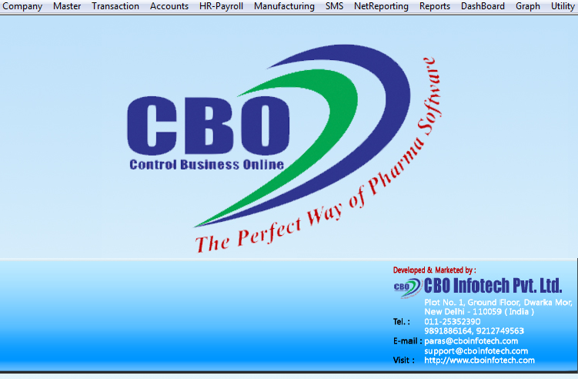

CBO Distribution

CBO Distribution Part

Company

Backup
- To create supplementary exact copies of files and Databases.
- Useful to restore your software when it crash.
For Back up the software
- Click on << Back up… >> menu . Aback up will be stored on your computer - > Click on Ok

Log Off
For Log Off the software

For Switch one Company to another Company login

Switch Company
- To login one to another Company / CNF etc

Exit
- To Exit form software
Click here to Exit from software

Master
In this Section you can Add all the Masters/ Heads.
- Party Master
- Account Group
- Item Master
- Batch Master
Click here to add your all Master / leaser
- Batch Opening
- Tax Master
- State
- Head Quarter
- CA/CF/SS Master
- etc…

Party Master
- In this section you can add the detail of your parties
  - Stockiest
  - Franchisee
  - Consignee
  - Super Stockiest
  - Doctor
  - Hospital
  - Supplier
  - Manufacturer
  - Supplier-Manufacturer
  - Distributor
  - Others

To Add Party Master
Click on Master- Party Master
After clicking on Party Master a form will be appear

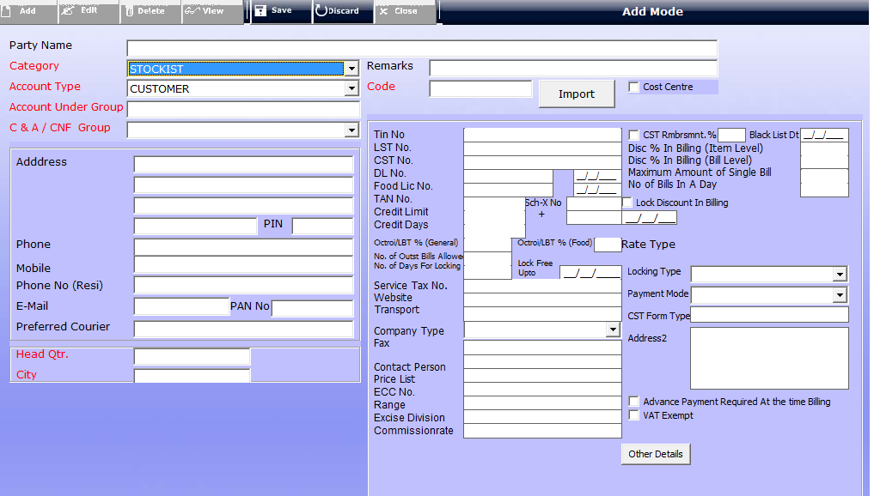

Step 2: Click on « Add » button
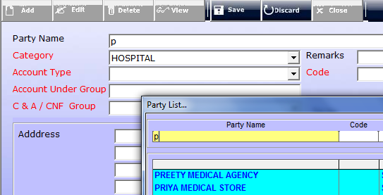

- Enter Party Name

Note:- If Party name Exists you cannot create same or duplicate party

- Choose Party category
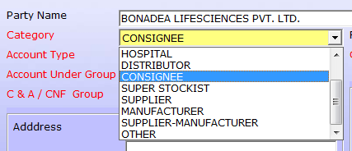

Note: - You have to choose any one Party category in this combo box

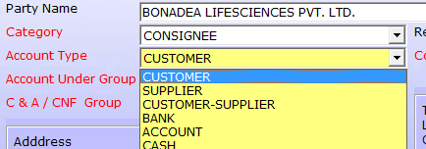
- Choose Party Account Type

Note: - You can choose any one Option for Party Account Type

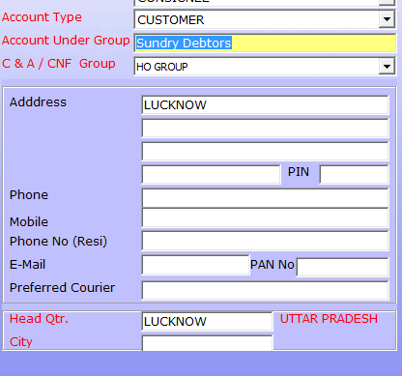
- Select Party Account under group
Press F1 to choose default account group
- Choose C&A /CNF group

- Fill full Address with Ph no., Email, Pan etc…

- Select Head Quarter press F1 to select Head Qtr. Name

Note: - If Head Quarter name not found first of all Add Head Quarter head with the help of “Head Quarter” head

- Add / Fill CST Rmb%, Black list Date, Disc% in billing (Item/Bill )level, Fix maximum amount of single billing, No of billing a day, and you can tick Lock discount in Billing
- Add Remark and Company code

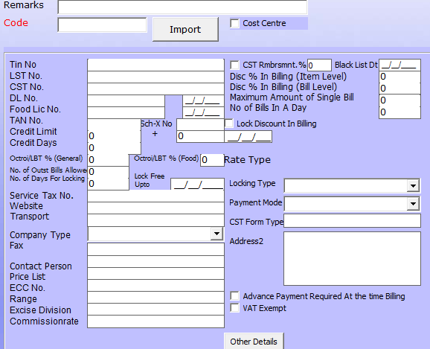
- Add / Fill Tin No, LST No., CST No., DL No, Food LIC No. with date
And TAN No. with date,

- Add / Fill Credit Limit and Credit days you can “+” credit amount or credit days ,And Chose Locking type warning message and Stop billing

- Add / Fill Service Tax no, website, transport, Company type, fax, contact person, etc..

- To Fill Other Details click on Other Details button a dialog box will be appear.

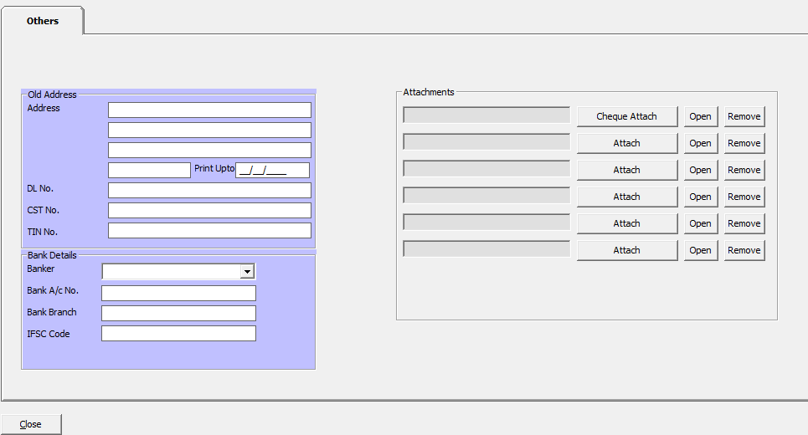
Step 3: Click on « Save » button to save the Party details
- You can attach chaque , and other valuable Documents.
- Fill Old Address and Bank Details of this party

To Edit Party Master
Step 1: Click on « Edit » button.

Step 2: Select Party Name to edit and Edit Them

Step 3: Click on << Save >> button for save the changes

To Delete Party Master
Step 1: Click on « Delete » button.

Step 2: Select Party Name to edit and Delete Them

Step 3: Click on << Delete >> button for Delete the party

Account Group
- In This Section you can add All Account ex (Bank A/c/, Bank OD Account, Assets, Liability……)
- We have some default Account already generated here you can easily update by click a single button << Update Default Account Group >>.
- If Account Name or Group not available in this default you can add Account Group

To Add Account Group
Step 1:- Click on Master- Account Group
Step 2: Click on « Add » button and fill all the details carefully and click on « Save »

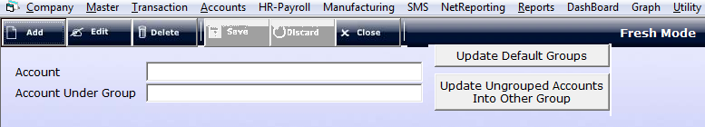

Note: - If Account name Exists you cannot create same or duplicate Account

To Edit Account Group
Step 1: Click on « Edit » button.

Step 2: Select the Account Group to edit.

Item Master
- In This Section you can used to enter the Item list of the Stock to maintain inventory.You have three option to tag your item
  - Original
    - Saleable items
  - Brands

  - Others
    - Gifts/ Stationary … Etc..
- In this Head you can Add / Edit /Delete and View the items

To Add a New item
- Help of this option you can Create a new Item in Item Master
Click on Master- Item Master Original
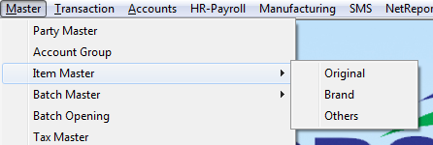
After clicking on Item Master a dialog box will be appear, where you would be required to mention all the following details regarding the New item.

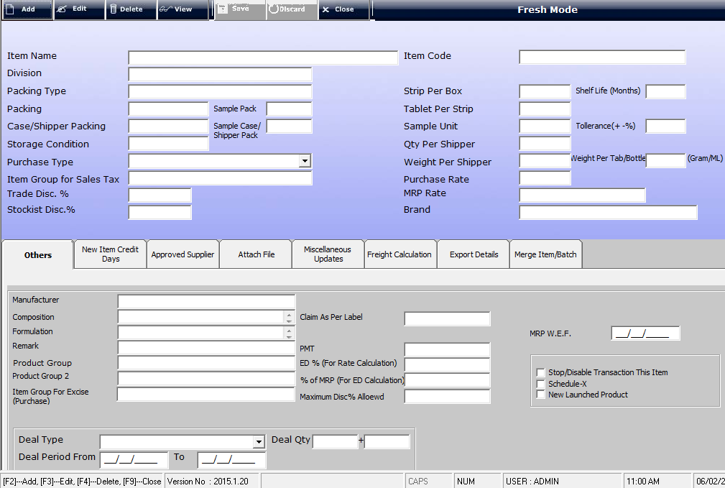
- Add :- To add the new item in this ERP
- Edit :- To Edit the item
- Item Name:- Name of the Item
- Division :- you can select division of this item( you have to create division first )
  - To create new division Click on Master Other Master Division
- Packing Type :- Packing type of the item(tablet/cap/ syp etc..), (press F1 to choose packing type)
  - To create new Packing Type Click on Master Other Master Packing Type
- Packing :- Packing of the item (press F1 to choose packing type)
  - To create new Packing Click on Master Other Master Packing
- Sample pack :- packing of the sample items
- Case/Shipper Packing:- case / shipper packing
- Storage condition :- by default maximum storage condition of the medicine is Cool otherwise you can choose different
- Purchase Type: - Either Trader or Manufacturer.
- Item Group: - You can make Item Group for sales tax (ex:- General Product / Food Product /Cosmetics etc..)
- Trade Disc%:- Discount % in trading
- Stockiest Disc%:- Item level discount % for Stockiest.
- Item Code:- Add nay code of item
- Strip Per Box
- Tablet Per Strip
- Sample Unit
- Qty per Shipper: - Qty in a Shipper Ex (10,1000 ect…;)
- Weight per Shipper:- Mention Weight per shipper Purchase Rate:- Mention the product Purchase Rate
- MRP Rate:- Mention the product M.R.P
- Brand:-
- Manufacturer:- Manufacturer of this Item
- Composition:- Add all composition of the Item
- Formulation:- All formulation of Item
- Product Group:- You can Create Product groups for tracking Sales etc.. (press F1 to choose Product Group)
  - To create new Product Group Click on Master Other Master Product Group
- Product Group2:- You can Create Product group2 for tracking Sales etc.. (press F1 to choose Product Group2)
  - To create new Product Group2 Click on Master Other Master Product Group2

- Item Group for Excise:-
- Claim As Per Label
- PMT
- ED % (for Rate Calculation)
- % of MRP ( For ED Calculation)
- Maximum Disc% Allowed: - you can fix the Maximum limit of the discount according to your choice.
- MRP W.E.F.
- Deal Type:- You can chose which type of deal you mentioned on
- Deal Qty:- Mention the Deal Quantity (Ex 10+1 means for per 10 box 1 box will be free for this item)
- Deal Period: - Mention the deal date / Period (eg, From 01/12/2014 to 31/03/2015)
- New Item Credit Days:- Mention Credit days of this item
  - Maximum Quantity of Billing:- Mention Maximum Quantity of billing
  - Credit days: Mention Credit Days for this Item only
- Attach File: - You can attach any document related to this item.
- Miscellaneous Updates:- You can update your all item here any modification then choose this Tab
- Export Item To Previous Financial Year:-

Batch Master
- In This Section you can used to enter the Batch name of the Stock to maintain inventory.
  - Original
    - Batch for the Original items
  - Brands
    - Batch for the brand item
  - Others
    - Batch of the other Item
- In this Head you can add / Edit /Delete and View the Batch.

To Add Batch Opening Stock
- Help of this option you can Create a Batch for the Item.
Click on Master- Batch Opening
After clicking on Batch Master a form will be appear

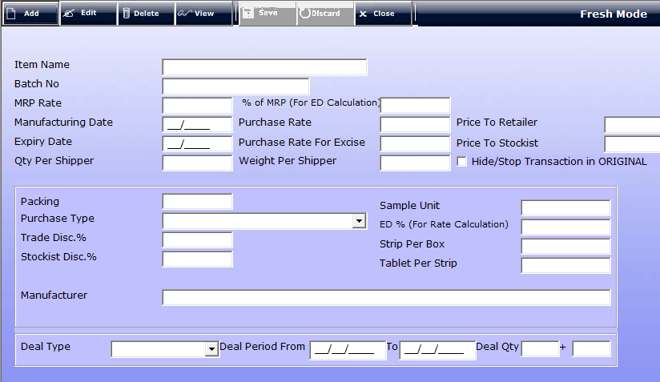

- Add :- To add the new Batch of item in this ERP
- Edit :- To Edit the Batch of the item
- Item Name:- Name of the Item
- Batch No: - Mention any batch no for an Item.
- MRP Rate: - Mention MRP rate of this Batch.
- % of MRP (For ED Calculation)
- Manufacturing Date:- Mention Mfg date of this Bach
- Purchase Rate: - Purchase rate of this Batch
- Price To Retailer:- Mention price of Retailer
- Expiry Date: - Mention Expiry date.
- Purchase Rate for Excise:-
- Price To Stockiest:- Mention Price of Stockiest of this batch
- Qty Per Shipper:-
- Weight Per Shipper:-
- Packing :- Packing of the item (press F1 to choose packing type)
- Sample Unit :-
- Purchase Type: - Either Trader or Manufacturer.
- Trade Disc%:- Discount % in trading
- Stockiest Disc%:- Item level discount % for Stockiest.
- Strip Per Box
- Tablet Per Strip
- Sample Unit
- Manufacturer:- Manufacturer of this Batch
- ED % (for Rate Calculation)
- Deal Type:- You can chose which type of deal you mentioned on
- Deal Qty:- Mention the Deal Quantity (Ex 10+1 means for per 10 box 1 box will be free for this Batch)
- Deal Period: - Mention the deal date / Period (eg, From 01/12/2014 to 31/03/2015)
- Export Item To Previous Financial Year:-

Batch Opening
- In This Section you can used to enter the Stock to maintain inventory.
- In this Head you can Add / Edit /Delete and View the Batch Opening stock.

To Add Batch Opening (Add Batch stock)
- Help of this option you can upload all the stocks in this software.
Click on Master-Batch Opening

After clicking on Batch Opening a form will be appear

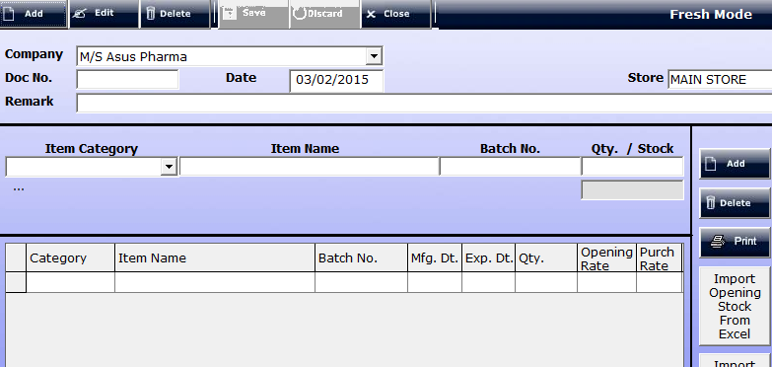

- Add :- To add the new Stock of item in this ERP
- Edit: - To Edit the Stock Entry of the item.
- Company Name:- Mention Name of the Company(Cnf/ Company name )
- Doc No: -Automatically Picked in Sequence
- Date: - Mention Date of the Opening Stocks.
- Store:- Chose your Store
- Item Category:- Select Item Category(eg.. Original , Brand/ Others, sample ,Etc..)
- Item Name:-Mention Name of the Item
- Batch No:- Select Batch no of this item
- Qty. / Stock: - Mention Your Stock quty. In your Store
- Add:- Click on add button to add in a stock
- Similarly for the other Item then save the form
- Delete: - For Delete a Item Stock
- Print: - To Print the detail click on Print.

Tax Master
- In This Master You Can Add Tax Heads
- We have a option to Create Default tax masters here by clicking g button << Upload Default Tax Master >>

To Add Tax Master
- Help of this option you can create New Tax Head.
Click on Master-Batch Opening

After clicking on Batch Master a form will be appear

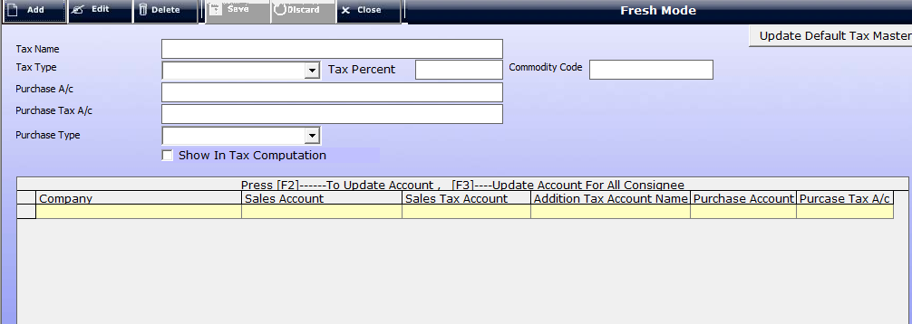

- Add :- To add the new Tax
- Edit: - To Edit the Tax.
- Tax Name: - Mention Name of the Tax.
- Tax Type: - Select Type of Taxes (Egs.. VAT, CST, EXPORT…. )
- Purchase A/C: - Mention Purchase A/c Percentage
- Purchase Tax A/C: - Mention Purchase Tax A/c Percentage
- Purchase Type: - Select Purchase Type (eg.. Local Purchase, With C Form, Without C Form, Etc..)
- After entering all details Click On Save to save the taxes

State Master
In this Section you can add state and fill tax rate over there, and Set Formula for Tax calculation.

To Add State Master
- Help of this option you can create New State Head.
Click on Master- State

After clicking on Batch Master a form will be appear

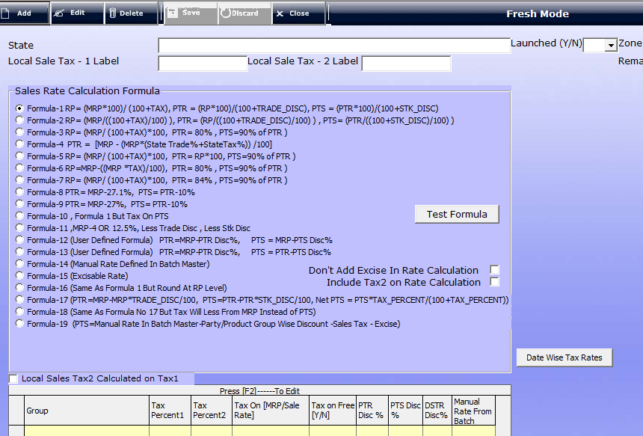

- Add :- To add the new State
- Edit: - To Edit the State Master Name And Taxes..
- State: - Mention Name of State.
- Local Sale Tax- 1 Label: - Select Sale Taxes (Eg.. VAT, )
- Local Sale Tax 2 Label: - Mention another label of Tax
- Launched : - Select Yes/ No
- Zone Name: - Select Zone Name (Eg.. Local East, West, North….)
- Sale Rate Calculation Formula : - Choose One formula to sale rate calculation
- Test Formula : To test your Formula
- Date Wise Tax Rate:-
- After entering all details Click On Save
- To Edit Tax rate Press F2

Head Quarter
- In This Section you can Create/ Edit / Delete Head Quarter Head

To Add Head Quarter
- Help of this option you can create New Head Quarter Head.
Click on Master- Head Quarter

After clicking on Head Quarter a form will be appear

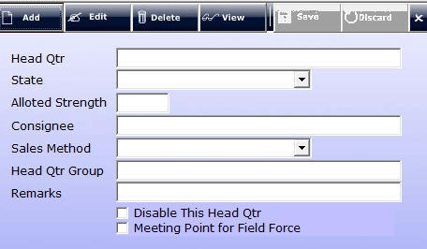

- Add :- To add the new Head Quarter
- Edit: - To Edit the Head Quarter details..
- Head Qutr: - Mention Name of Head Quarter.
- State: - Mention State Name of the Head Quarter.
- Allotted Strength: - Mention Employee Strength of the head Quarter
- Consignee : - Select name of the Consignee in this Head quarter/ optional
- Sales Method: - Choose Sales Method (Eg. Manual/ Automatic)
- Headquarter Group : - Mention The head Quarter Group
- After entering all details Click On Save

CA/C&F/SS Master
- In This Section you can Create/ Edit / Delete CA/ C&F/ Super Stockiest Authentication details to use Our Software
- You can Add or Create Invoice bill Format of CA/ C&F/ Super Stockiest.

To Add CA/C&F/SS
- Help of this option you can create New Authentication of CA/C&F/SS.
Click on Master- CA/C&F/SS Master

After clicking on Head Quarter a form will be appear

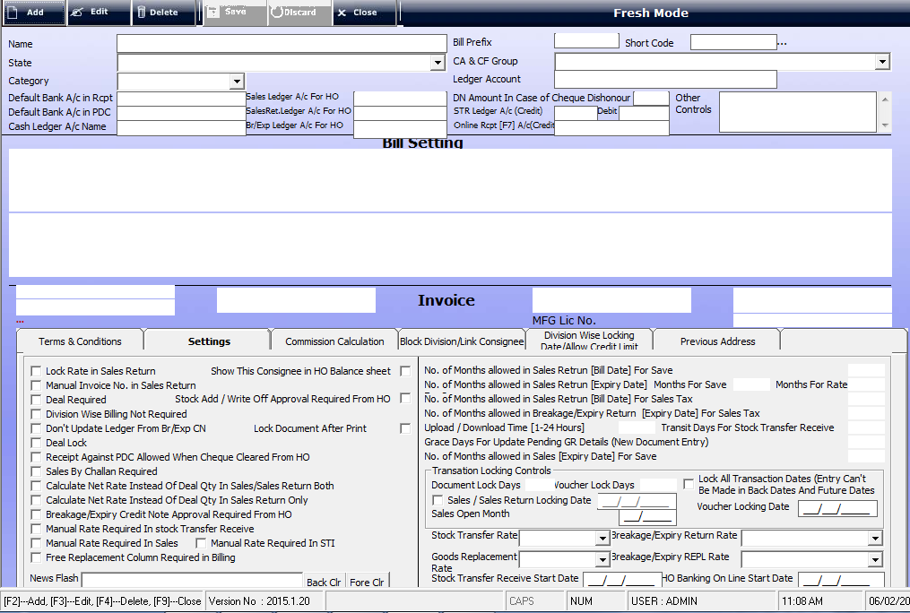

- Add :- To add the new CA/ C&F/ SS
- Edit: - To Edit the CA/ C&F/ SS details Authentication and formats..
- Name: -= Mention the name of CA/ C&F/ SS.
- State: - Select State Name of the CA/ C&F/ SS
- Bill Prefix:- Add bill Prefix which you want to print on your bill
- Short Code.
- CA and CF Group:- Chose Group CA and CF Group
- Category: - Select Category of CA/ C&F/ SS (Eg. HO, CNF, CA, SS etc…).
- Ledger Account:- Mention Ledger name of this CA/ C&F/ SS.
- Default Bank A/c RCPT
- Sales Ledger A/ C for HO
- DN Amount In Case Of Cheque Disc.
- Default Bank A/C in PDC
- Cash Ledger A/C Name
- Sales Ret. Ledger A/c For HQ
- Br/ Exp Ledger A/c For Head Quarter
- STR ledger A/c (credit)
- Online Rcpt [F7] A/C (Credit)
- Term & Conditions: - Mention Your Term and Condition which you want to print on your Invoice Bill Format.
- Settings: - In This Section you can give the controls/ Authentications and Set Detail format to the CA/ C&f/ CS and HO.
  - Sales/Sales Return Locking Date
  - Stock Rate Transfer: - You can Chose Stock transfer Rate (eg.. Sale Rate, MRP, PTD Rate and Purchase Rate)
  - Goods Replacement Rate:- Breakage/ Exp Return Rate
  - Stock Transfer Receive Start Date
  - Breakage/ Exp Return Rate: - You can Chose in MRP, RP, Trade Rate.. etc.
  - Breakage/ Exp REPL Rate: - You can Chose in MRP, RP, Trade Rate... etc...
  - Ho Banking Online Start Date
- Commission Calculation
- Block Division/ Link Consignee
- Division Wise Locking date Allow Credit Limit

State/Head Qutr/Party wise block Product
- In This Section you can Block any Product to any State/Head Qurtr/Party .

To block State/Head Qurtr/Party wise Product
- Help of this option you can block any product Party wise, state wise or Head Quarter Wise.
After clicking on Head Quarter a form will be appear

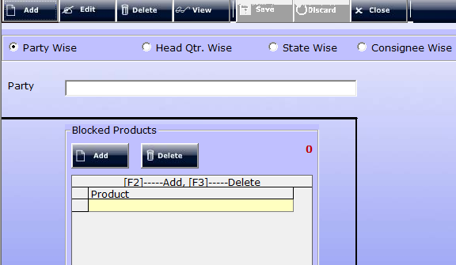

- Add :- To add the Product to block
- Edit: - To edit the block items.
- Choose any one of them to block the product Party Wise, Head Qtr. Wise , State wise or Consignee wise
- Party: -Mention the name of party (to Find Press F1)
- To Block the Product
  - Press F2 to add the Product.
  - Press F3 To delete Added Product..
- Click on save button to save.

.Stockiest or Consignee wise Deal
- In This Section you can create Deals for Stockiest or Consignee.

To Create a Deal for Stockiest / Consignee.
- Help of this option you can add any Deal to Stockiest and Consignee..
After clicking on Head Quarter a form will be appear

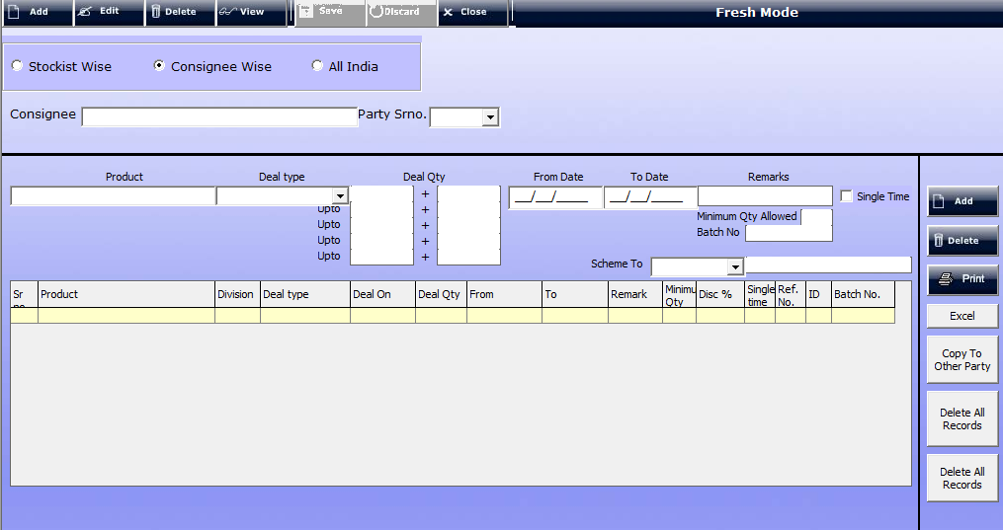

- Choose any one of them deal of the product Stockiest Wise, Consignee Wise and All India Wise.
- Consignee: -Mention the name of Consignee (To Find Press F1)
- Product: - Mention Name of the Product for Deals.
- Deal Type: - Choose Deal Type (Full, Exact, Half ETC...)
- Deal QTY
- From Date :- Deal Start Date
- To date :- Deal End Date
- Add:- To add The Filled Item
- Delete:- To delete the filled products

.Special Rate
- In This Section you can create Special rate of an item to special parties.

To Create Special rate for Stockiest.
- Help of this option you can add special rate for Stockiest..
After clicking on Head Quarter a form will be appear

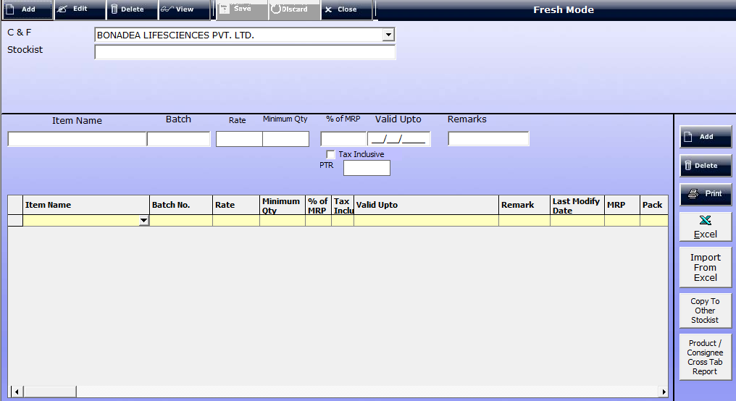

- Consignee: -Select the name of Consignee (To Find Press F1)
- Stockiest: - Mention Name of the Stockiest for Special Rates.
- Item Name: - Mention Name of the Item for special rate.
- Batch No: - Choose Batch no of the Item
- Rate: - Mention Special rate to that item .
- Minimum Qty: - Mention minimum qty of this Product.
- Add:- To add The Filled Item
- Delete:- To delete the filled products
- Print :- To Print The Filled/ Added Items

. CST Party Define
- In This Section you can Define CST Party (Party, Outside of the headquarter).

To Define CST Party
- Help of this option you can define Out sate party for Billing.
After clicking on Head Quarter a form will be appear

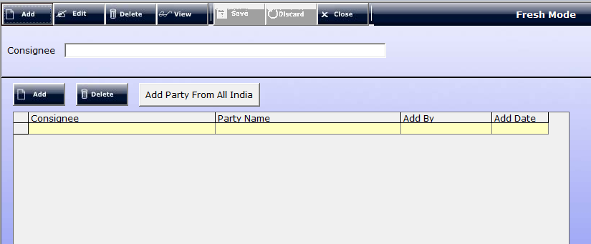

- Consignee: -Select the name of Consignee (To Find Press F1)
- Stockiest: - Mention Name of the Stockiest for Special Rates.
- Add:- To add The Party in CST Party List
- Delete:- To delete the Party in CST Party List

. Other Master
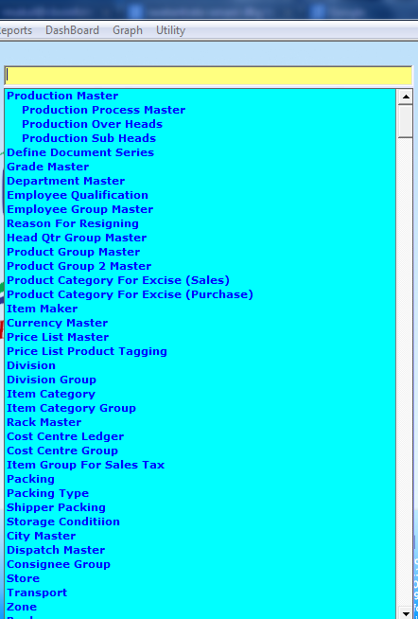
- In this Section You can create many heads or Subheads to Support Main Parties .

Transaction
After Creating Masters for the company (HO/ C&F/ Supplier/customers/ etc), the next step is to record all the transactions with that company. Transactions are nothing but a record of items sold or purchased, credit is extended or borrowed, income is made or expenses are assumed on a daily basis.
Entering transactions means keeping a detailed inventory of entries in vouchers such as Sale, purchase, payment, receipt, etc.
This feature allows you to add, modify and list different vouchers.
Click on Transactions.

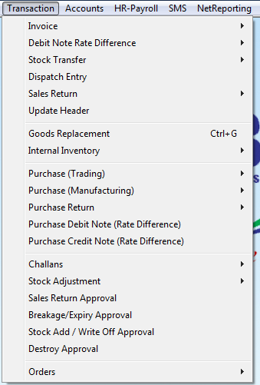

1. Invoice
- You can enter the Sales made in the business under the Invoice.
- You can enter sales related details by using the Invoice.
- To create, modify, or delete a Sale, the Transactions menu provides the Invoice option.
- It is a proof of your sale on which you will receive the payment.
- Our ERP Allow You these option
  - Tax Invoice:- Party with tin no comes under Tax Invoice
  - Retail Invoice: - Bill of the Party without Tin No.
  - CST Invoice :- For CST Party billing
  - Export Invoice :- To Out States Party bill for Export
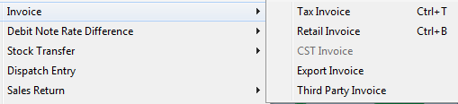
  - Third Party Inv:- Other Party not define in Party master

- Click on Transaction Invoice Tax Invoice/ Retail invoice /etc..
- On clicking the Tax Invoice option, a window will display.
- In this window you can make the bill to the party
- You have to define some entries in it for accuracy of your records.
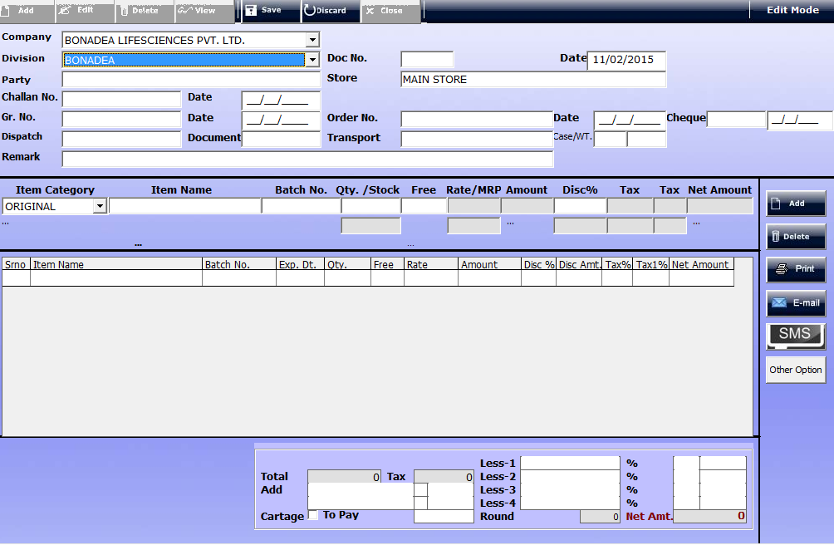

- Division: - Select Your Division of billing.
- Doc:- Automatically Picked
- Date: - define the transaction date on which you have sold the product.
- Party: - Name of the Party to whom you are going to sale.
- Store:- Mention Your Store Name Press F1
- Chalan No:- Enter Chalan No
- Date:- Mention The Date of the Chalan
- GR. No :- Goods Receive No.
- Date:- and Goods Receive Date
- Order No:- Mention Order No of this bill
- Date:- Mention Date Of Order Number
- Cheque:- Enter Cheque no if any and date.
- Dispatch:- Enter Dispatch Courier
- Transport:- Mention Transport option
- Item Category: - Select Item Category (eg.. Original, Brand/ Others, sample, Etc..)
- Item Name:-Mention Name of the Item
- Batch No:- Select Batch no of this item
- Qty. / Stock: - Mention Your Stock quty. In your Store
- Free:- Mention free if applicable
- Disc%- Mention Disc % if any
- Add:- Click on add button to add item to be Sold.
- Delete: - For Delete a Item
- Less % 1/.. :- If you want some less in your total then you mention less Persentage
- Print: - To Print the detail click on Print.

2. Debit Note Rate Difference
- In accounts there were many instances when an Organization receive debit note or it has to issue a debit note to its suppliers, customers, employees, third party and so on.
- Suppose you have purchased an item at a rate of Rs.100 however by mistake your supplier had billed you at a rate of Rs.95, then your supplier may issue a debit note for balance of Rs. 5 plus vat and other applicable duty. In such a case, you have to debit respective purchase and duty amount as narrated in the debit note and credit the supplier account.
- Similarly if you have issued a debit note to your customer, you have to debit your customer’s account and credit the related account.
- I am highlighting some major circumstances under which you may issue or receive a Debit Note
1) Rate difference in sales/purchase invoice
2) Difference between billed and actual quantity of the invoice
3) Interest on late payment to and from suppliers/customers
4) Recovery interest or any amount from employees due to loss or damage to company’s assets or any other cause.
- Our ERP Allow You these option
  - Debit Note Rate Difference Tax Invoice:- Party with tin no comes under Tax Invoice
  - Debit Note Rate Difference Retail Invoice: - Bill of the Party without Tin No.
- Click on Transaction Debit Note Rate Difference Debit Note Rate Difference Tax Invoice/ Retail invoice /etc..
- On clicking the Debit Note Rate Difference Tax Invoice option, a window will display.
- In this window you can make the bill to the party
- You have to define some entries in it for accuracy of your records.
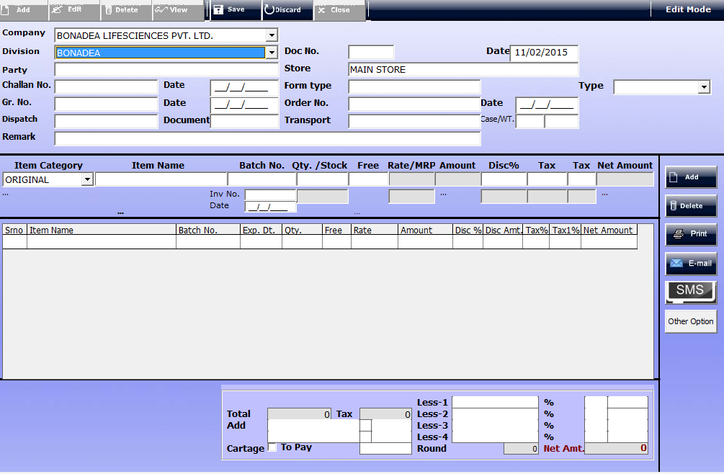

- Division: - Select Your Division of billing.
- Doc:- Automatically Picked
- Date: - define the transaction date on which you have sold the product.
- Party: - Name of the Party to whom you are going to sale.
- Store:- Mention Your Store Name Press F1
- Chalan No:- Enter Chalan No
- Date:- Mention The Date of the Chalan
- GR. No :- Goods Receive No.
- Date:- and Goods Receive Date
- Order No:- Mention Order No of this bill
- Date:- Mention Date Of Order Number
- Cheque:- Enter Cheque no if any and date.
- Dispatch:- Enter Dispatch Courier
- Transport:- Mention Transport option
- Item Category: - Select Item Category (eg.. Original, Brand/ Others, sample, Etc..)
- Item Name:-Mention Name of the Item
- Batch No:- Select Batch no of this item
- Inv no- Mention the Invoice no against the debit note difference
- Qty. / Stock: - Mention Your Stock quty. In your Store
- Free:- Mention free if applicable
- Disc%- Mention Disc % if any
- Add:- Click on add button to add item to be Sold.
- Delete: - For Delete a Item
- Print: - To Print the detail click on Print.

3. Stock Transfer
- This is used to record all the transaction for which an organization has provided all goods and services to its customers. A track of all stocks/goods which are supplied can be maintained by the organization after posting an entry under this option.
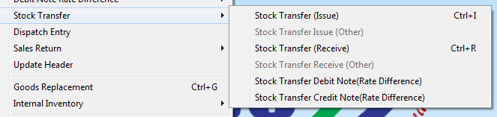
I

Stock Transfer issue
- With the help of Stock Transfer Issue option we can Transfer the stock from one godown to another, or Godown to C&F etc.
- it is used to issue the consignment , no any outstanding will be shown regarding this transaction.
Add New Stock Transfer Issue
Click on Transactions Stock Transfer Stock Transfer Issue.
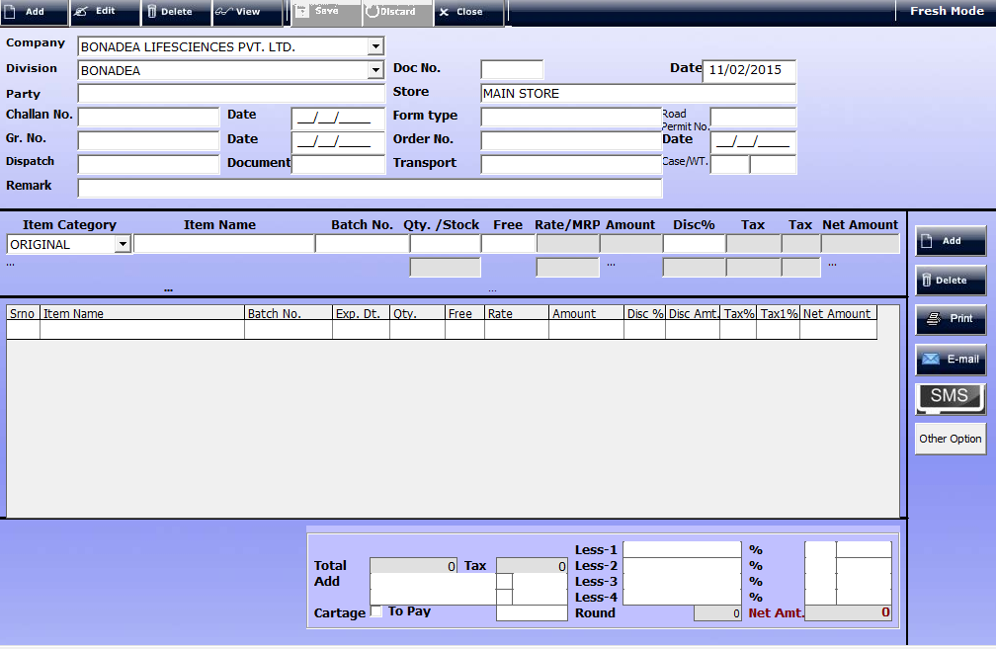

- Division: - Select Your Division to transfer the goods.
- Doc:- Automatically Picked
- Date: - Define the transaction date on which you have Transfer the product.
- Party: - Name of the Party to whom you have receives goods.
- Store:- Mention Your Store Name Press F1
- Chalan No:- Enter Chalan No
- Date:- Mention The Date of the Chalan
- GR. No: - Goods Receive No.
- Date:- and Goods Receive Date
- Order No:- Mention Order No of this bill
- Date:- Mention Date Of Order Number
- Cheque:- Enter Cheque no if any and date.
- Dispatch:- Enter Dispatch Courier
- Transport:- Mention Transport option
- STI No:- Mention Stock transfer Issue No.
- Item Category: - Select Item Category (eg.. Original, Brand/ Others, sample, Etc..)
- Item Name:-Mention Name of the Item
- Batch No:- Select Batch no of this item
- Inv no- Mention the Invoice no against the debit note difference
- Qty. / Stock: - Mention Your Stock quty. In your Store
- Free:- Mention free if applicable
- Disc%- Mention Disc % if any
- Add:- Click on add button to add item to be Sold.
- Delete: - For Delete a Item
- Print: - To Print the detail click on Print.
- Stock would be automatically updated

Stock Transfer Receive
- With the help of Stock Transfer Receive option we can receive the stock from one godown to another, or Godown to C&F etc.
Add New Stock Transfer Receive
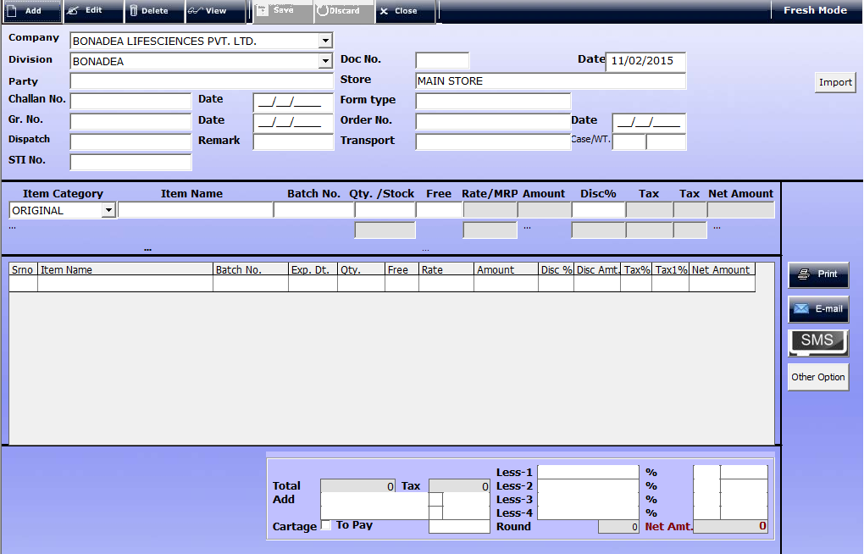
Click on Transactions Stock Transfer Stock Transfer Receive.

- Division: - Select Your Division of stock receive .
- Doc:- Automatically Picked
- Date: - Define the transaction date on which you have Transfer the product.
- Party: - Name of the Party to whom you have supplied goods/services.
- Store:- Mention Your Store Name Press F1
- Chalan No:- Enter Chalan No
- Date:- Mention The Date of the Chalan
- GR. No :- Goods Receive No.
- Date:- and Goods Receive Date
- Order No:- Mention Order No of this bill
- Date:- Mention Date Of Order Number
- Cheque:- Enter Cheque no if any and date.
- Dispatch:- Enter Dispatch Courier
- Transport:- Mention Transport option
- Import: - To Import all the sending stock for that Party.
- Item Category: - Select Item Category (eg.. Original, Brand/ Others, sample, Etc..)
- Item Name:-Mention Name of the Item
- Batch No:- Select Batch no of this item
- Inv no- Mention the Invoice no against the debit note difference
- Qty. / Stock: - Mention Your Stock quty. In your Store
- Free:- Mention free if applicable
- Disc%- Mention Disc % if any
- Add:- Click on add button to add item to be Sold.
- Delete: - For Delete a Item
- Print: - To Print the detail click on Print.
- Stock would be automatically updated
PROCESS TO MAKE AN ENTRY FOR SELF BREAKAGE/WASTE/EXPIRED AND STORE

Stock Transfer Debit / Credit Note Rate Difference
  - If we have some waste/breakage/expired items in our stock which is non refundable than we can less that stock from our current stock with the help of these option.
    - Debit Note :- To less the stock
    - Credit Note:- To Add the stock difference

Add New Stock Transfer Debit/ credit note difference
Click on Transactions Stock Transfer Stock Transfer Debit note.
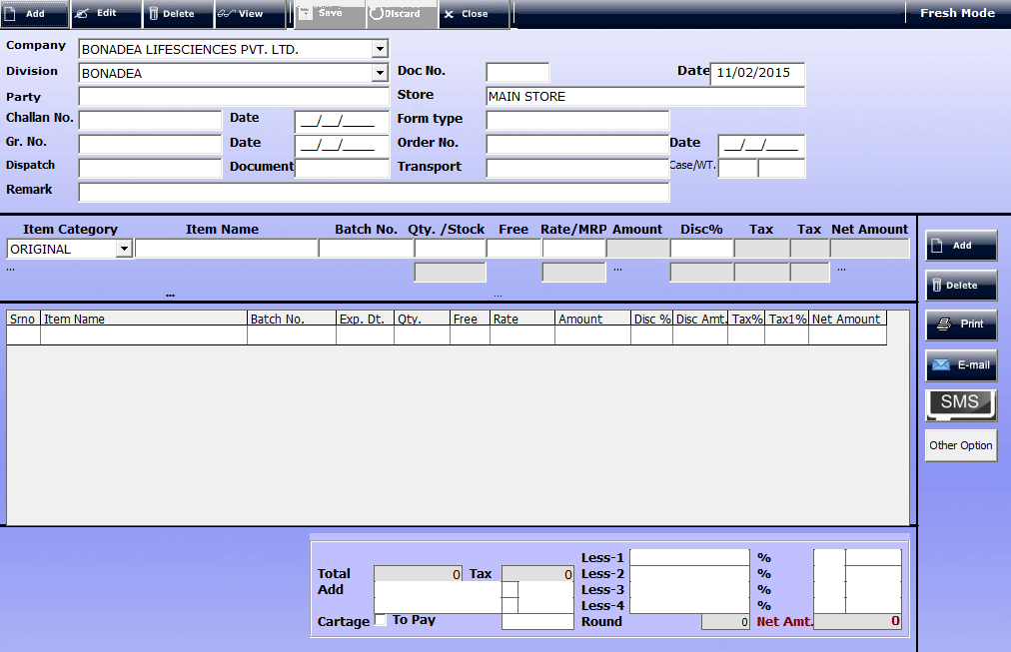

Also if we want to transfer the goods from one store to another than we can make an entry by this option.

- Division: - Select Your Division of stock receive .
- Doc:- Automatically Picked
- Date: - Define the transaction date on which you have Transfer the product.
- Party: - Name of the Party to whom you have supplied goods/services.
- Store:- Mention Your Store Name Press F1
- Chalan No:- Enter Chalan No
- Date:- Mention The Date of the Chalan
- GR. No :- Goods Receive No.
- Date:- and Goods Receive Date
- Order No:- Mention Order No of this bill
- Date:- Mention Date Of Order Number
- Cheque:- Enter Cheque no if any and date.
- Dispatch:- Enter Dispatch Courier
- Transport:- Mention Transport option
- Import: - To Import all the sending stock for that Party.
- Item Category: - Select Item Category (eg.. Original, Brand/ Others, sample, Etc..)
- Item Name:-Mention Name of the Item
- Batch No:- Select Batch no of this item
- Inv no- Mention the Invoice no against the debit note difference
- Qty. / Stock: - Mention Your Stock quty. In your Store
- Free:- Mention free if applicable
- Disc%- Mention Disc % if any
- Add:- Click on add button to add item to be Sold.
- Delete: - For Delete a Item
- Print: - To Print the detail click on Print.
- Stock would be automatically updated

4. Dispatch Entry
- In this section you can enter Dispatch time Entry if goods is not Dispatched in same time

- Doc No:- Automatically Picked
- Date: - Define the Dispatch date on which you have Dispatch the product.
- Party: - Name of the Party to whom you have Dispatch goods.
- GR. No :- Goods Receive No.
- GR. Date:- and Goods Receive Date
- Cheque:- Enter Cheque no if any and date.
- Transport/ Courier :- Mention Transport option
- Case: - Select No of cases
- Weight:-Mention weight of the Product
- Builty Amount: - Mention builty amount if any.
- Email:- You Can Email this or print this

5. Sales Return
- If the goods/stocks which are sold, being returned is quite common. This can happen for a variety of reasons like defects in goods, quality standards not matching with the required quality demanded, buyer not requiring stock, etc. So when these goods which were sold earlier are returned, this process is called Sales Return.
- These transactions of goods being returned, like any other accounting transactions have to be recorded in books of account.
- These transactions are recorded under contra revenue account. Considering a transaction of credit sales, two elements that would be affected will be the sales A/C and the buyer A/C. Sale of stock, being an income, the sales A/C is credited and the buyer being a benefit receiver, buyer A/C is debited. Therefore, in case of sales return, sales A/C is debited and Buyer A/C is credited.
- We trace all the stock/goods that is returned. For doing this an organization has to issue a credit note which list the items that have to be re-delivered to the customer. Hence, it shows the amount of stock/goods that the organization owes to its customers.
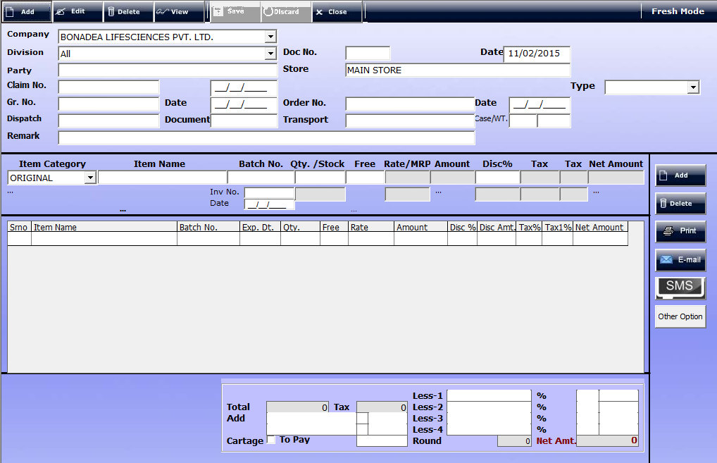
Click on Transactions Sales Return Sales Return Credit (tax/ Retail ) note

- Division:
- - Select Your Division of Sales return .
- Doc:- Automatically Picked
- Date: - Define the Sales Return date on which you have Sales Return the Product.
- Party: - Name of the Party to whom you have return goods.
- Store:- Mention Your Store Name Press F1
- Type:- Mentioned and Select Goods Return or else
- Chalan No:- Enter Chalan No
- Date:- Mention The Date of the Chalan
- GR. No: - Goods Receive No.
- Date:- and Goods Receive Date
- Order No:- Mention Order No of this bill
- Date:- Mention Date Of Order Number
- Cheque:- Enter Cheque no if any and date.
- Dispatch:- Enter Dispatch Courier
- Transport:- Mention Transport option
- Import: - To Import all the sending stock for that Party.
- Item Category: - Select Item Category (eg.. Original, Brand/ Others, sample, Etc..)
- Item Name:-Mention Name of the Item
- Batch No:- Select Batch no of this item
- Inv no- Mention the Invoice no against the debit note difference
- Qty. / Stock: - Mention Your Stock quty. In your Store
- Free:- Mention free if applicable
- Disc%- Mention Disc % if any
- Add:- Click on add button to add item to be Sold.
- Delete: - For Delete a Item
- Print: - To Print the detail click on Print.
- Stock would be automatically updated
- The credit note would be recorded in the sales return book

6. Goods Replacement
- This is used to record all those transaction for which an organisation has provided replacement for goods which were returned by its customers on account of defects in goods, quality standards not matching with the required quality demanded, buyer not requiring stock,
- Click on Transactions Goods Replacement
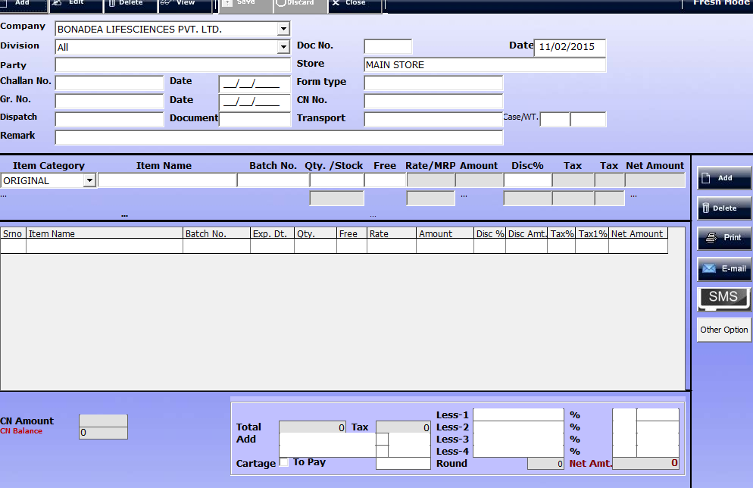

- Division: - Select Your Division.
- Doc:- Automatically Picked
- Date: - Define the Sales Return date on which you have Sales Return the Product.
- Party: - Name of the Party to whom you have replaces goods.
- Store:- Mention Your Store Name Press F1
- Type:- Mentioned and Select Goods Return or else
- Chalan No:- Enter Chalan No
- Date:- Mention The Date of the Chalan
- GR. No: - Goods Receive No.
- Date:- and Goods Receive Date
- Order No:- Mention Order No of this bill
- Date:- Mention Date Of Order Number
- Cheque:- Enter Cheque no if any and date.
- Dispatch:- Enter Dispatch Courier
- Transport:- Mention Transport option
- Item Category: - Select Item Category (eg.. Original, Brand/ Others, sample, Etc..)
- Item Name:-Mention Name of the Item
- Batch No:- Select Batch no of this item
- Inv no- Mention the Invoice no against the debit note difference
- Qty. / Stock: - Mention Your Stock quty. In your Store
- Free:- Mention free if applicable
- Disc%- Mention Disc % if any
- Add:- Click on add button to add item to be Sold.
- Delete: - For Delete a Item
- Print: - To Print the detail click on Print.

Internal Inventory
- In this section we can change internal inventories example To change Original item to sample and Sample to Original, Internal Stock transfer from ex Stockiest to Stockiest, self breakage issue and Brakes expiry destroy

Conversion (Original to Sample and Sample to Original)
- In this section you can convert item Sample to original and Original to sample
- Click on Transactions Internal Inventory Original/ Sample Conversion
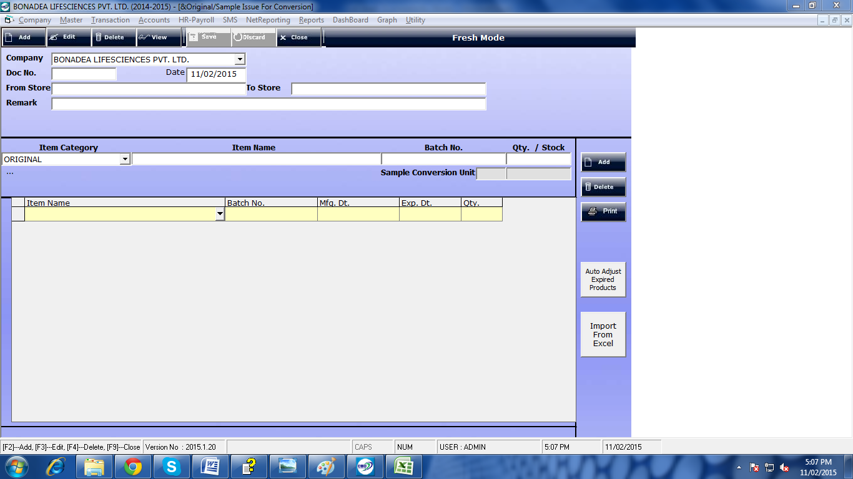

- Doc:- Automatically Picked
- Date: - Define the Conversion date on which you have converted the Product.
- From Store :- Mention Store name
- Item Category:- Choose Original or Sample.
- Item Name: - Name of the item to whom you want to convert..
- Batch No:- Enter batch No
- Qty. / Stock: - Mention Your Stock quty. In your Store
- Add:- Click on add button to add item to be converted.
- Delete: - For Delete a Item
- Print: - To Print the detail click on Print.

